PERIODIC TEST-II (2022-2023)
MARKS OBTAINED

TOTAL MARKS: 30
NAME: _________________________
SUBJECT: English
GRADE: I _____
DATE: 26.08.2022
TIME: 1 ½ Hours
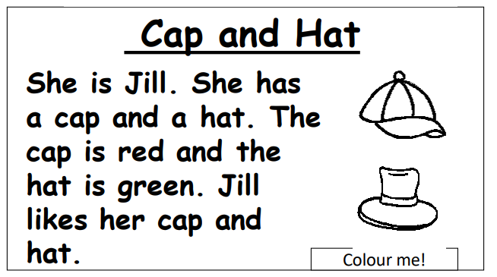
I. Read the passage and answer the questions. (4x1=4)

1.Jill has _________________
- Hat and can
- Cap and hen
- Cap and hat

2.The hat is ___________________

3.Do you have a cap or a hat?
______________________________________________________
4.Where do you wear a cap?
_________________________________________________________

II. Identify and circle the verbs. (8x1/2 =4)
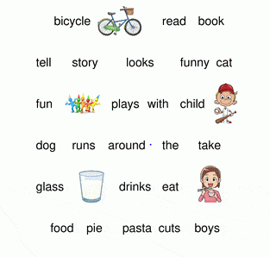
III. Complete the word with correct blend (l, s, r). 4x1=4
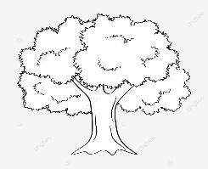
- T ___ ee

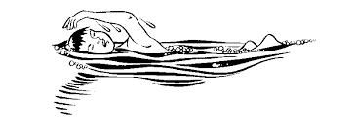
6. ____ wim

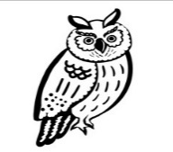
7. Ow ____

8. F___ag

IV. Answer the following. 4X2=8
9. What is Ammu’s job in the kitchen?
____________________________________________________________________________________________________________________________________________________________________________________
10.Where does Mrs. Kamala Ravi works?
____________________________________________________________________________________________________________________________________________________________________________________
11.Why does Malathy visit the post office ?
____________________________________________________________________________________________________________________________________________________________________________________
12. List the different vegetables that Appa uses to make samosas.
____________________________________________________________________________________________________________________________________________________________________________________

V. Identify the picture and write what the person does. 2X3= 6
13.

This is a____________________
What does the person do?
____________________________________________________________________________________________________________________________________________________________________________________

14.
This is a____________________
What does the person do? ____________________________________________________________________________________________________________________________________________________________________________________
VI. Can you think of two more people who help us in our everyday life? Name them and how they help us? (1x4=4)

